Automatic Purchase order system for Stock module:

Now the system has the ability to automatically submit purchase orders from the Stock Module.
Go to Settings >> Suppliers and double click on the suppliers to go to supplier information page
We have newly introduced the option “Purchase order send method”, below is the screenshot below for reference.
If the “Manual” radio button is selected this is the usual way how the purchase order will be generated for Stock items and will be available in the Pending orders and you have manually go and submit it
If “Automatic” is selected based on the email ID that has been mentioned in the main supplier as well as the Fabric supplier the order report will automatically emailed to the suppliers
Main Supplier Page
Fabric Supplier Page:

Email template for the automatic email.
You can set the email template for the automatic Purchase order report. To get that configured kindly go to Settings >> Email Templates
And go to “Auto Email Templates” Tab and you will find the “Stock Purchase order” template, you have to select the check box next to it to use it, and also you can design the email template by selecting it.

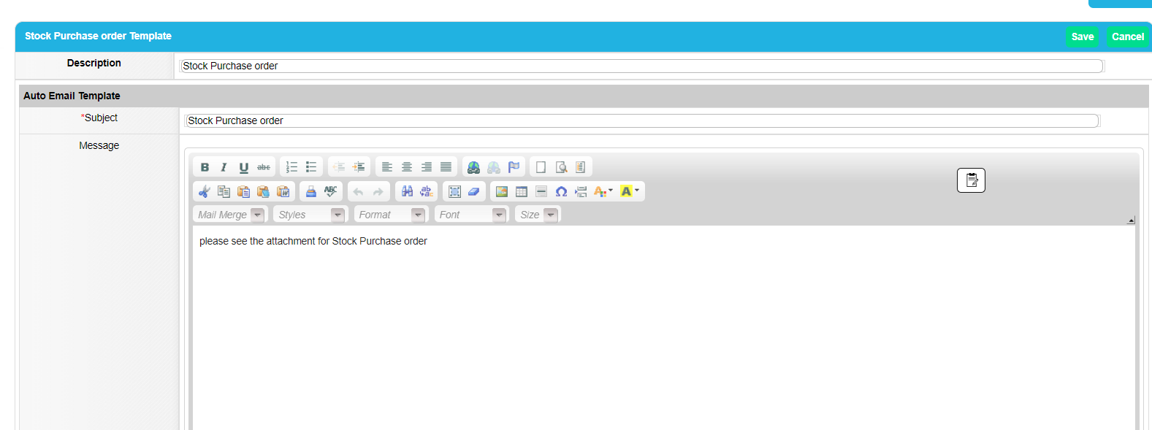
From email ID:
The stock update could be done form any user in the application so for this automatic purchase order you have to set a default address in the “From email ID” in the email settings. Below is the screenshot for reference

Stock module:
When the automatic purchase order is configured the order report will automatically be emailed and the PO reports will be shown in the “Purchased tab” as shown below

Once the components and the Fabrics are received you have to go and manually mark them as receive, this process remains the same.

